**SERVICE MANUAL**

1. **LOGIN WITH DEFINER LOGIN AND SELECT CREATE REPORT.** 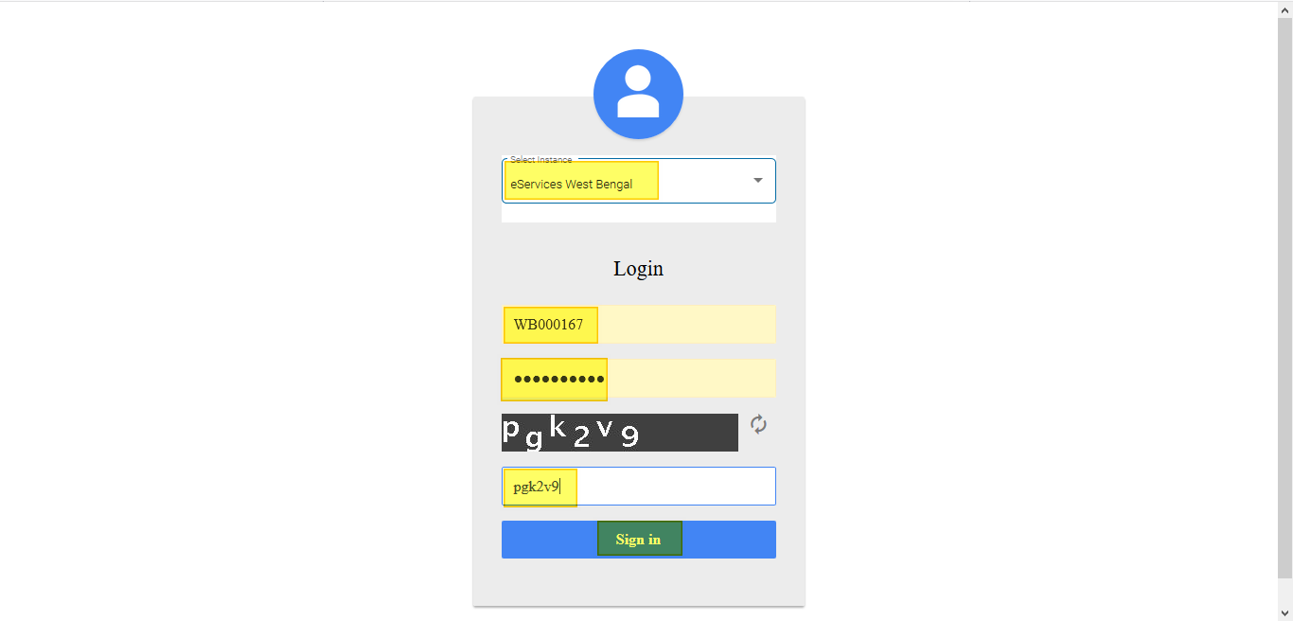

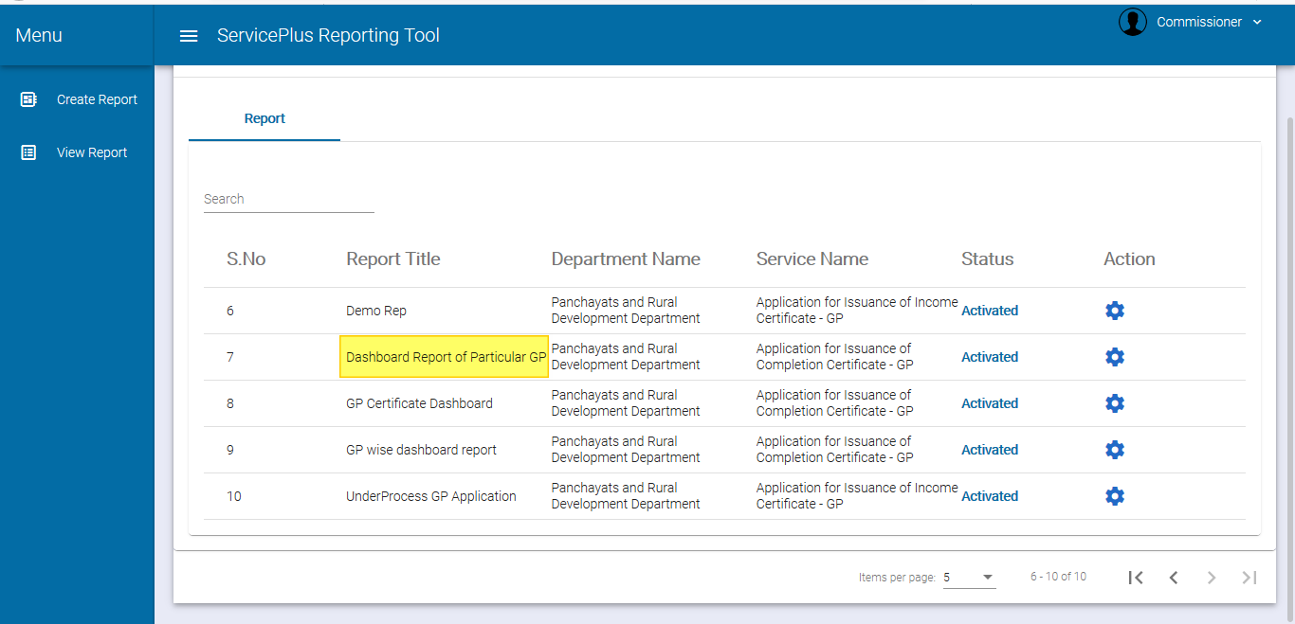

1. **SELECT DEFINITION AND FILL ALL DETAILS.**

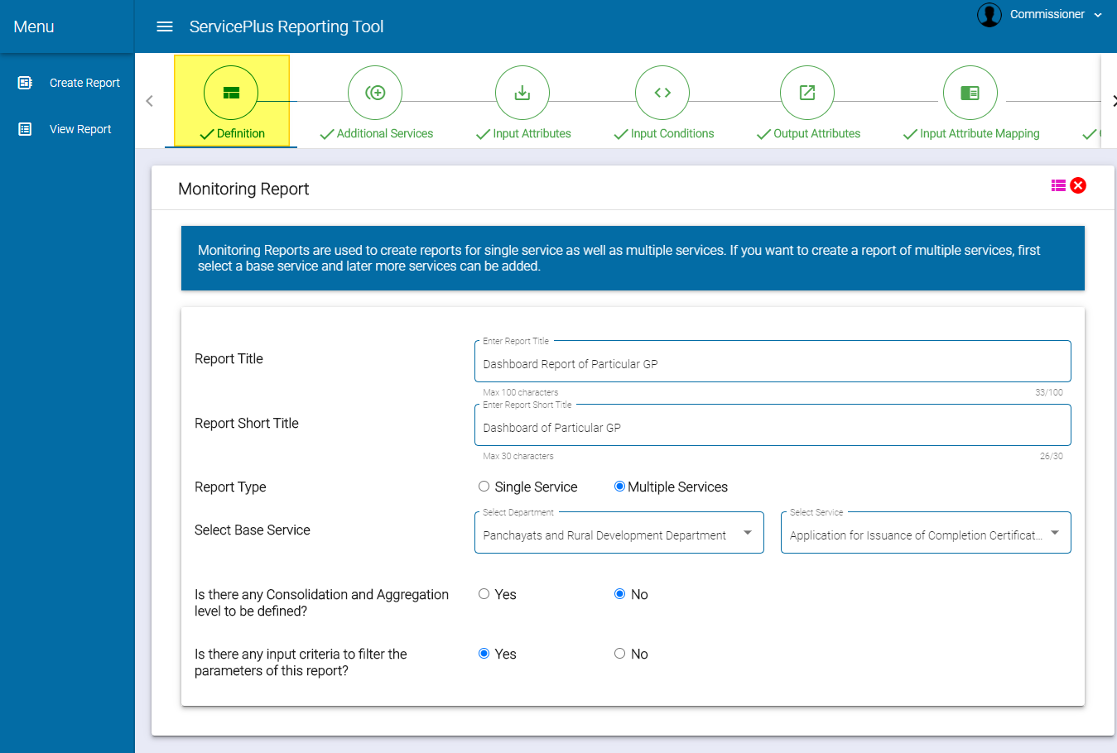

1. **SELECT ADDITIONAL SERVICES.**

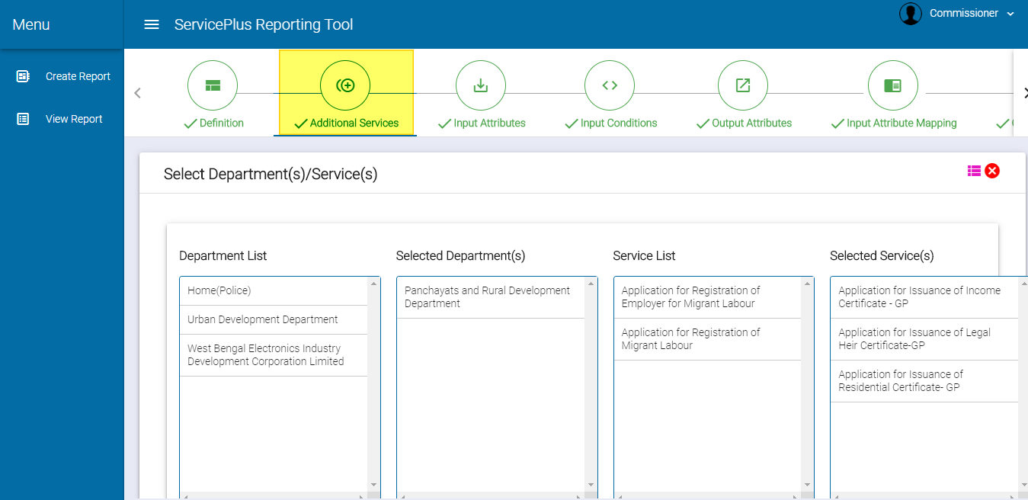

1. **INPUT ATTRIBUTES.**

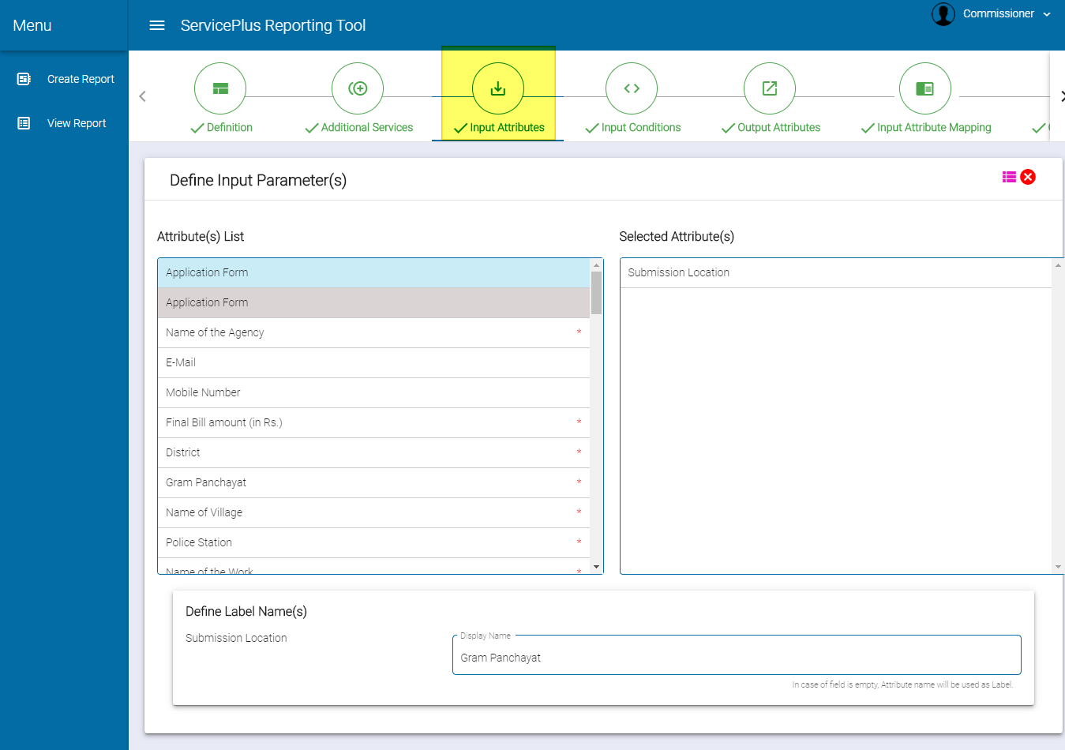

1. **INPUT CONDITIONS.**

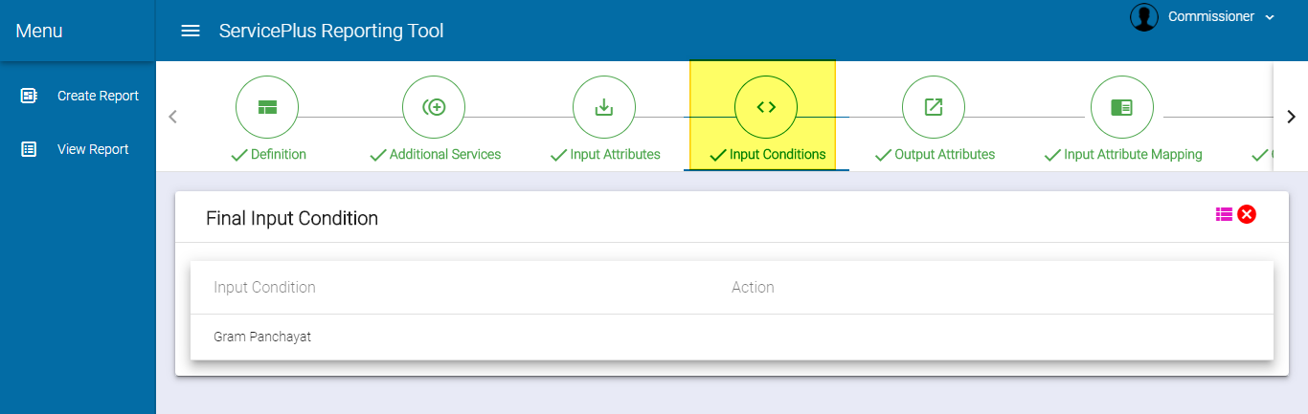

1. **OUTPUT ATTRIBUTES.**

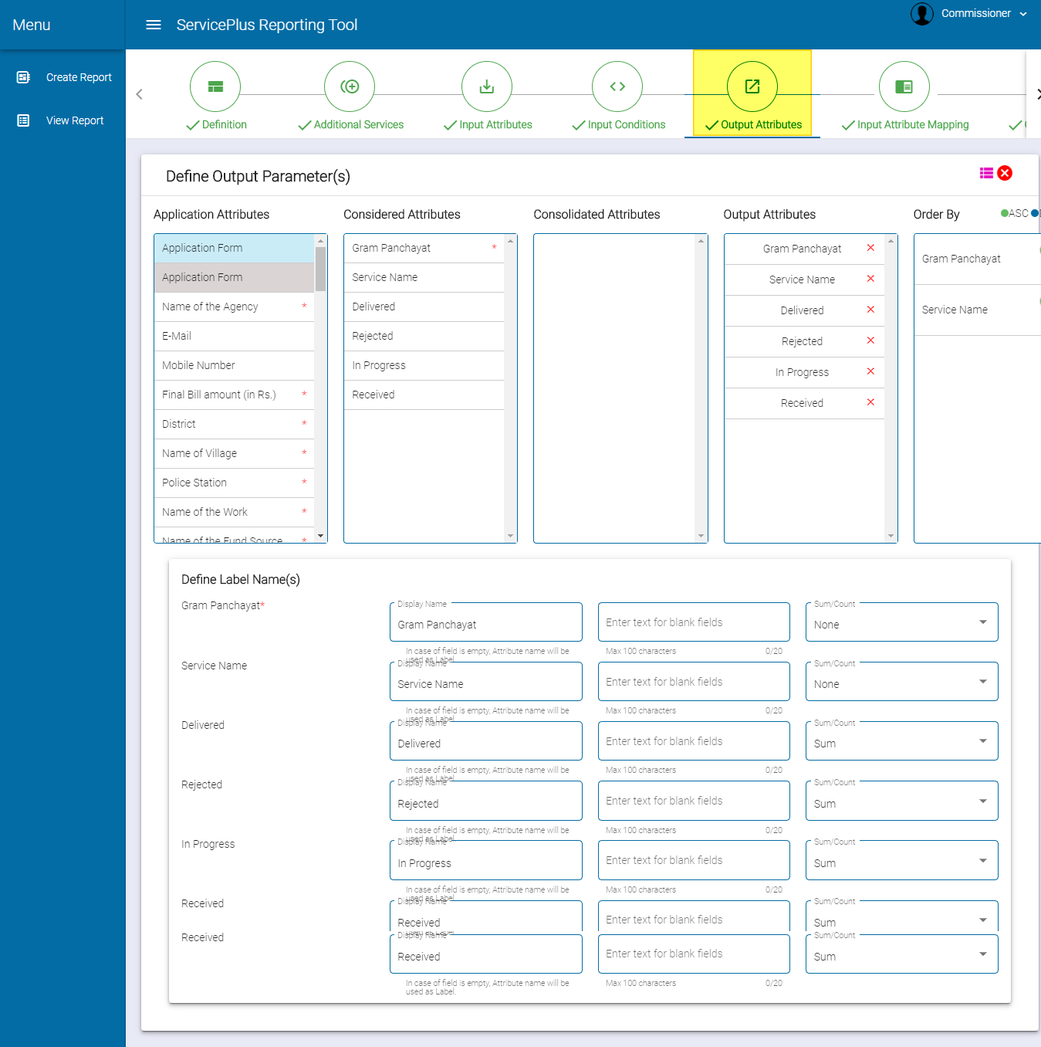

1. **INPUT ATTRIBUTE MAPPING.**

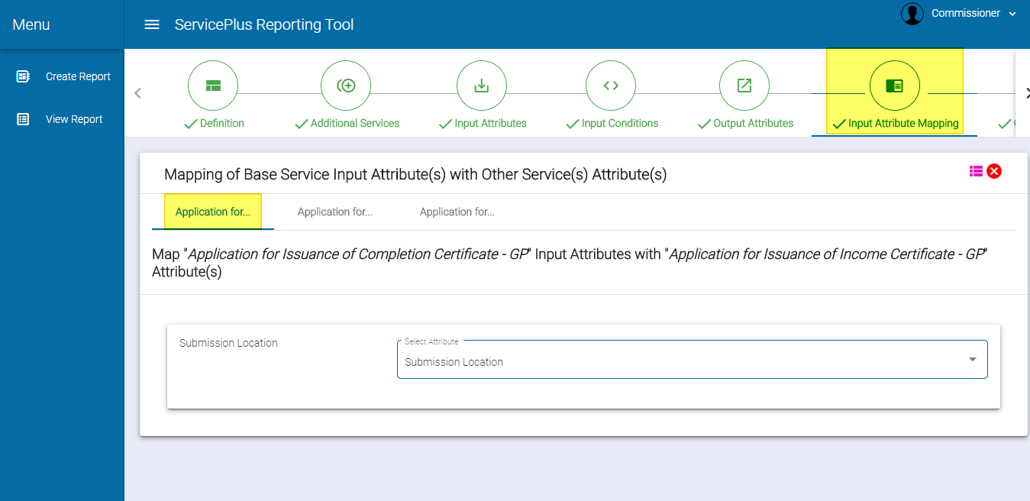

1. **OUTPUT ATTRIBUTE MAPPING.**

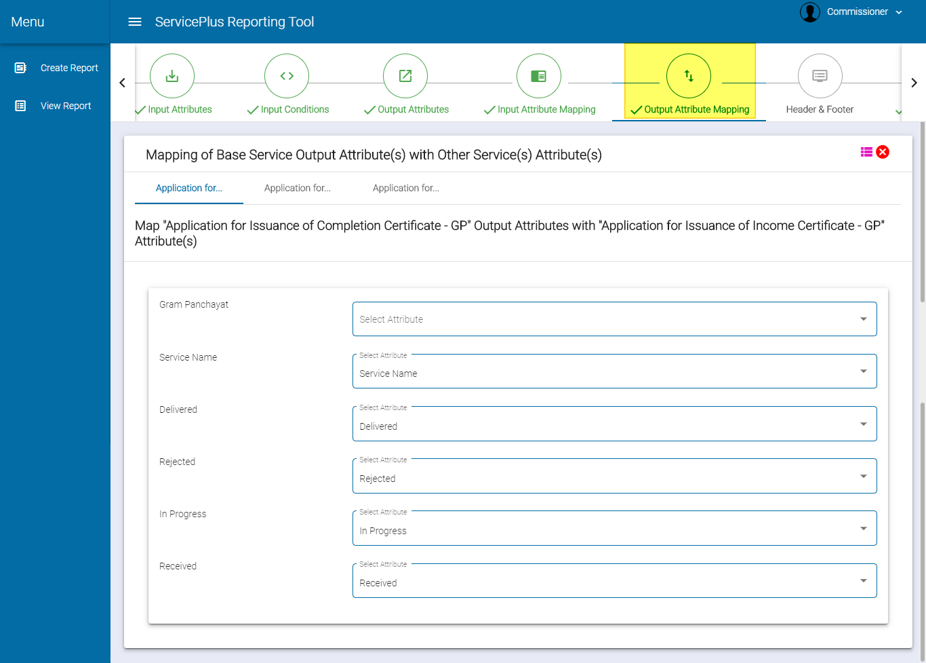

1. **ACCESSABILITY**

